Introduction :

- To implement dhcp server using python

Program :

server.py

sends the ip address ‘172.18.5.31’ to client.

import socket
server_socket = socket.socket(socket.AF_INET,socket.SOCK_DGRAM)
server_socket.bind(('127.0.0.1',9070))
max_bytes=65535
while True:
(data,address) = server_socket.recvfrom(max_bytes)
print("client details : ",address)
ip='172.18.5.31'
server_socket.sendto(ip.encode(),address)

client.py

sets the ip_address given by server to wifi interface .
import socket
import os
max_bytes=65535
client_socket = socket.socket(socket.AF_INET,socket.SOCK_DGRAM)
address=(socket.gethostname(),9070)
while True:
text=''
client_socket.sendto(text.encode(),('127.0.0.1',9070))
data,address=client_socket.recvfrom(max_bytes)
if ('127.0.0.1',9070)==address:
new_ip_address=data.decode()
ip_address='sudo ifconfig wlo1 '+new_ip_address
os.system(ip_address)
break

output :

before assignment
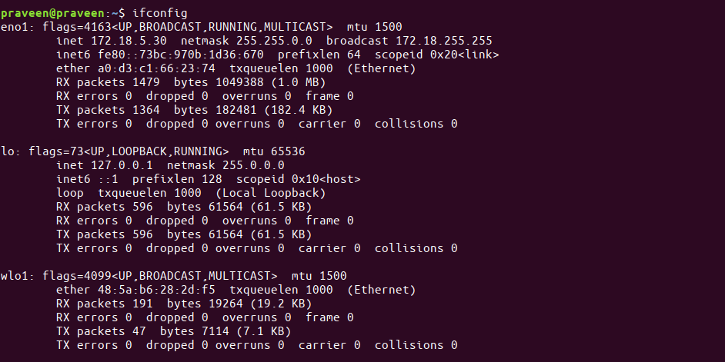

after assignment

